Python Turtle Graphics – Beginners Level 1

How to Create a Turtle Window.
To create a turtle window on your computer screen, please open a new file editor window and type the following code snippet. Save it as window1.py
from turtle import Turtle
t=Turtle()
t.screen.exitonclick()

When you run this program, you will get this result on your screen.
You can see an arrow head at the middle point of the window pointing to the east which is the default position. This location is called home.
The position of the turtle is specified with the two-dimensional coordinate system, (x,y).
The default position of the turtle(arrow head) is (0,0) which is the center of the window.
To make the turtle window disappear after viewing the turtle screen when you click on the turtle canvas, use the method screen.exitonclick() .
When you run the code snippet above the turtle screen won’t disappear immediately unless you click on the turtle canvas.

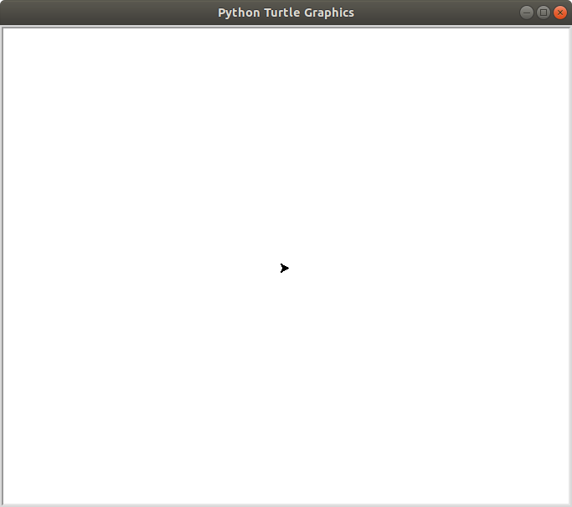
How to Change the Turtle Window Background Color

The default background color is white which can be boring. You can change it using the method screen.bgcolor()

To change the color of the turtle window background, please open a new file editor window and type the following code snippet. Save it and run.
from turtle import Turtle
t=Turtle()
t.screen.bgcolor(‘black’)
t.screen.exitonclick()

The screen.bgcolor() method accepts one argument which is the color of the turtle window as a string. The default color of Python turtle window is white.
When you run this program, you will get this result on your screen.
The background color of the turtle window is black but there is no turtle because the default color of the turtle is black.

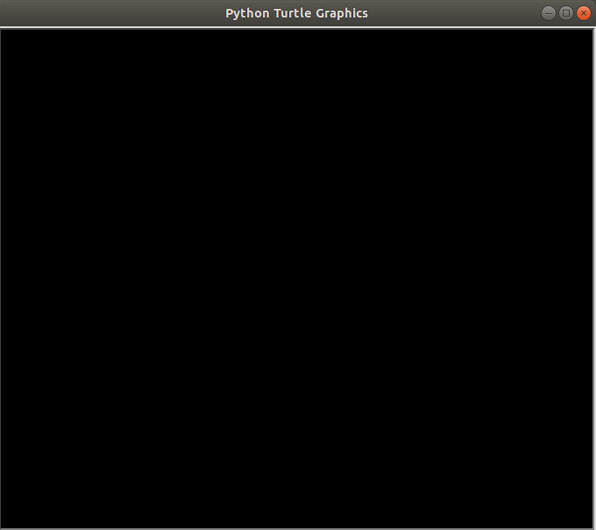

How to Change the Color of the Turtle

To change the color of the turtle,

Type the following code snippet into a new file editor and save it as any name you like.
from turtle import Turtle
t=Turtle()
t.screen.bgcolor(‘black’)
t.color(‘red’)
t.screen.exitonclick()

When you run this program, you will get this result on your screen.

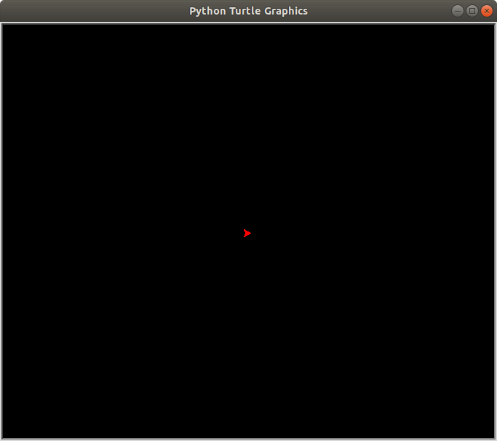

How to change the Background picture of the Turtle Screen.
Here’s a code snippet that changes the background image of the turtle screen (turtle_pic.py) .
How to change the turtle background image
from turtle import Turtle
t=Turtle()
t.hideturtle()
t.screen.bgpic("turtle.gif")
t.screen.exitonclick()

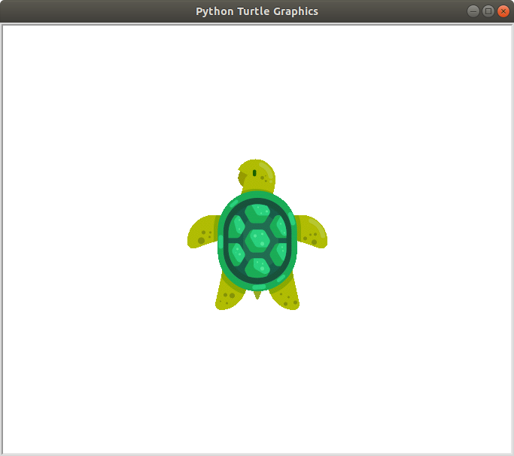

How to Set the Heading of the Turtle
By default the turtle faces the east, to change the direction in which the turtle is facing

from turtle import Turtle
t=Turtle()
t.hideturtle()
t.screen.bgpic("turtle.gif")
t.setheading(180)
t.screen.exitonclick()

The syntax is,

t.setheading(angle)

Angle 90 sets the turtle to face the North. Angle 180 sets the turtle to face the West. Angle 270 sets the turtle to face the South. Angle 360 or 0 set turtle to face the East
You can set the turtle to face any angle of your choice.

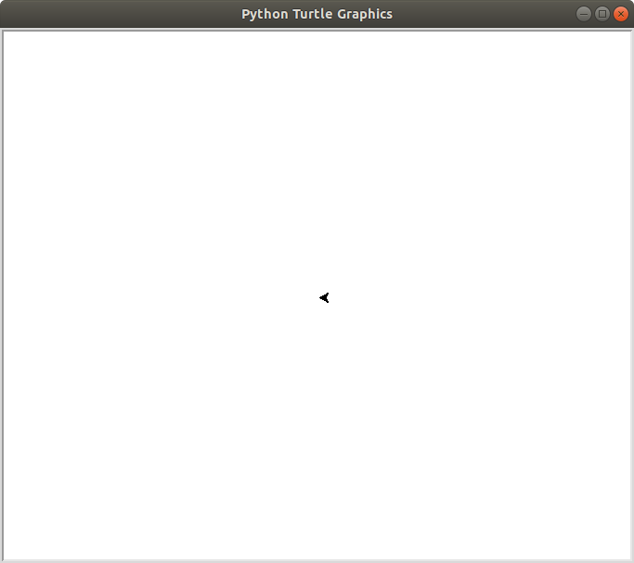
You can change the direction of the turtle using the following syntax

t.left(angle)

t.right(angle)

How to Change the Turtle Shape

The default shape of a turtle is known as a classic.
To change the shape of the turtle you use the shape() method.
The shape() method accepts a string as an argument. The string is the name of a valid shape in the TurtleScreen’s shape dictionary.
The valid turtle shapes are:
Arrow, Circle, Square, Triangle, Turtle, Classic
Open a new file editor window and type the following code snippet.

from turtle import Turtle
t=Turtle()
t.shape(“turtle”)
t.screen.exitonclick()

Change the turtle to the other types to see them
From the above screenshot, the turtle is small. To increase the size of the turtle, use the shapesize() method.

Add
t.shapesize(20)

Change the shapesize to different numbers to see how if looks.
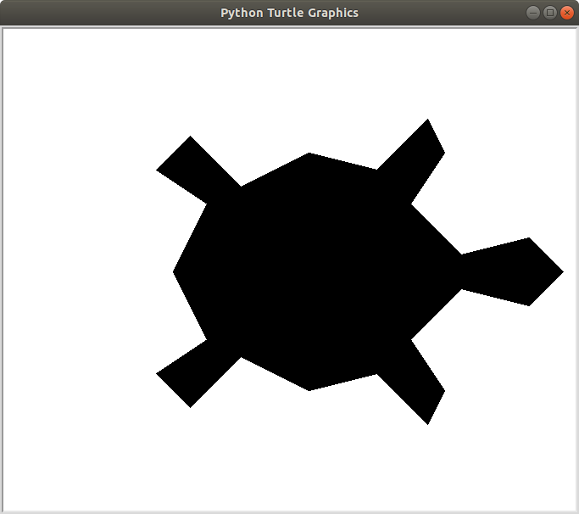

How to draw a dot

The dot() method receives two optional arguments, which are:
The size of a dot
The color of the dot
Here is a simple dot of size 20 and blue in color.
Here is the code snippet.
Python turtle code snippet to draw a dot

from turtle import Turtle

t = Turtle()
t.screen.bgcolor("black")
t.hideturtle()
t.dot(20,"blue")

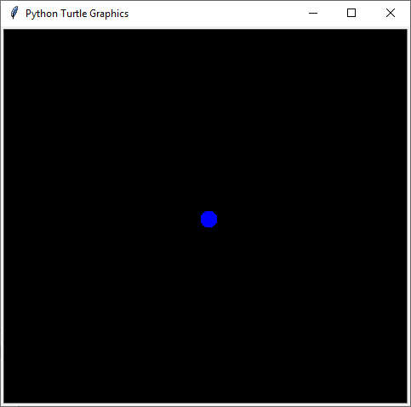
How to Draw a Line
To draw a line use the syntax below

t.fd(distance)
or
t.goto(x,y)

distance is the value of the length of the line. t.goto(x,y) moves the turtle to an absolute position
t.fd(distance) moves the turtle by the specified distance.

Open a new file editor window and type the following code snippet.
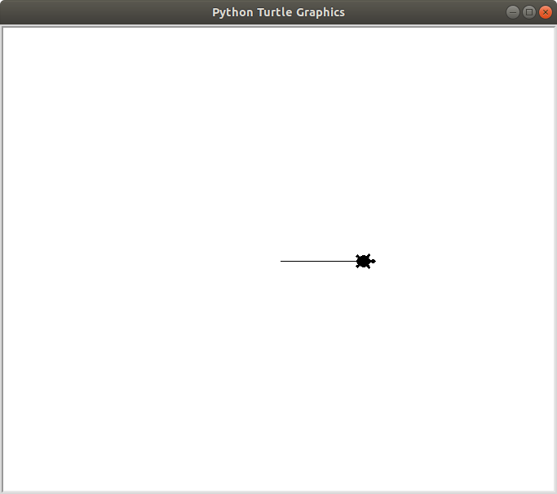
from turtle import Turtle
t=Turtle()
t.shape(“turtle”)
t.fd(100)
t.screen.exitonclick()

When you run the program above you will get:

The above program moves the turtle 100 pixels to the east.

Open a new file editor window and type the following code snippet.

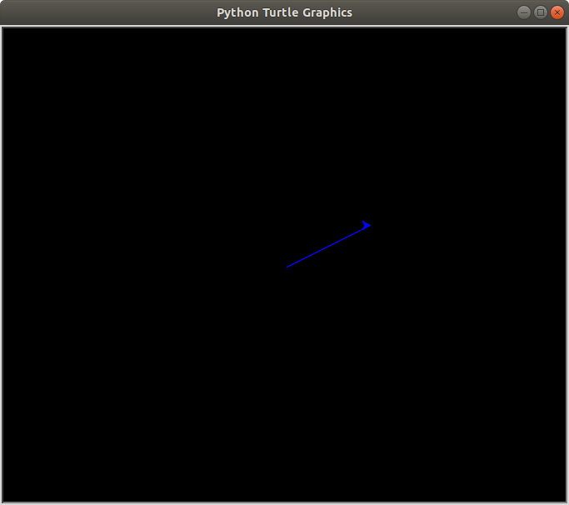
from turtle import Turtle
t=Turtle()
t.shape(“turtle”)
t.fd(100)
t.screen.exitonclick()

And then change to to following.
from turtle import Turtle
t=Turtle()

t.screen.bgcolor("black")
t.color("blue")
t.goto(100,50)

How to Increase the Thickness of a Line

t.pensize() accepts an integer as an argument to set the thickness of the line.

Open a new file editor and type the following code.

from turtle import Turtle
t=Turtle()
t.screen.bgcolor("black")
t.color("blue")
t.pensize(10)
t.fd(100)

when you run the code snippet above, you will get:
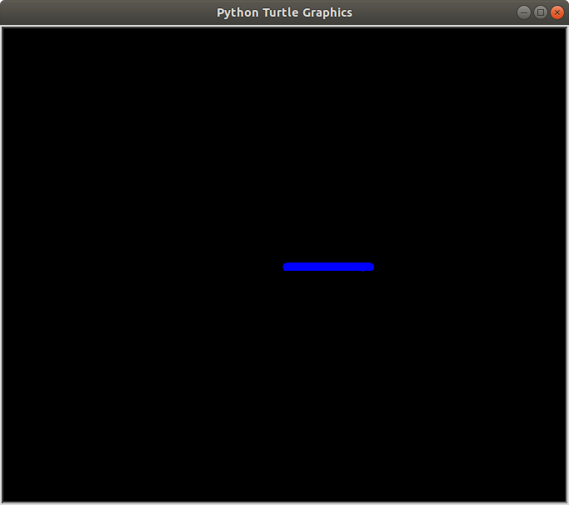
How to Hide the Turtle(Arrow Head)

You may not need the turtle to appear in your drawing as you just need a line. To achieve this open a new file editor and save the following code snippet as draw_line_without_turtle.py
Hiding turtle

from turtle import Turtle
t=Turtle()
t.fd(100)
t.hideturtle()

Running this program will give you,

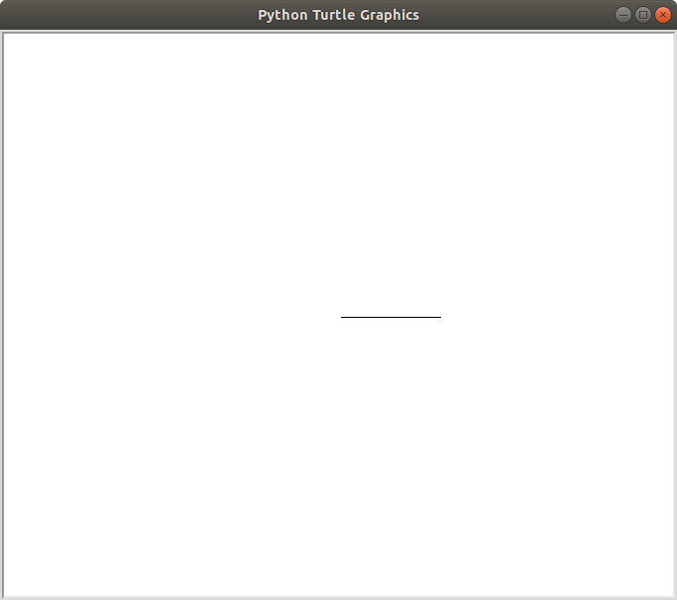

You have learned a lot, so let us do something fun with Python.

Project 1: Draw a square

Write a program to draw a square on the computer screen

Let the background screen color be black and color of the line drawn red.

Drawing a Square

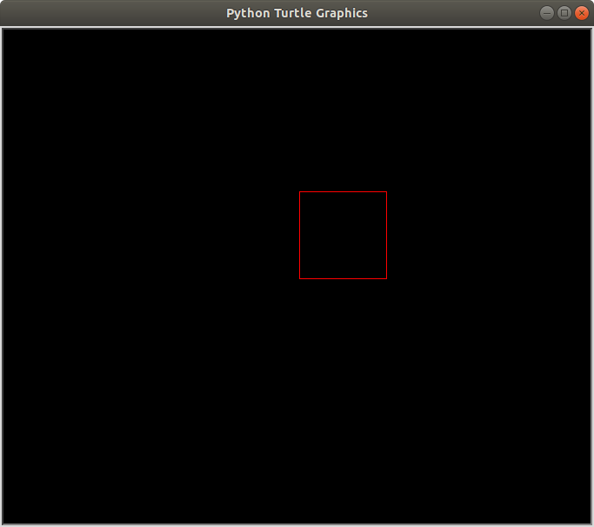
from turtle import Turtle
t=Turtle()
t.screen.bgcolor("black")
t.color("red")
t.hideturtle()
t.fd(100)
t.left(90)
t.fd(100)
t.left(90)
t.fd(100)
t.left(90)
t.fd(100)

The above program first changes the window background to black and the turtle to red using
t.screen.bgcolor(“black”) and t.color(“red”).

The turtle is then made invisible using this line of code t.hideturtle()
The turtle moves 100 pixels to the east (t.fd(100)) and draws a horizontal line.
It then faces the north by rotating 90 degrees ( t.left(90)) to the left and moves 100 pixels to the north, drawing a vertical line.
t.left(90) makes the turtle face the west by rotating it 90 degrees left. It then moves 100 pixels to the west, drawing a horizontal line.
t.left(90) makes the turtle face the south by rotating it 90 degrees left. It then moves 100 pixels to the south, drawing a vertical line.
The turtle turns 90 degrees left to face the east, it then moves 100 pixels to the east which is the default position of the turtle.
Finally, a square is drawn.

Solution 2: Draw Square
Let’s make our code more readable and maintainable with function and a for loop.

Drawing a square with function and for loop

from turtle import Turtle
t=Turtle()
t.screen.bgcolor("black")
t.color("red")
t.hideturtle()

def square(length):
for steps in range(4):
t.fd(length)
t.left(90)

square(100)

Basically, the for loop runs through the code below four times.

t.fd(length)
t.left(90)

Project 2: Draw rectangle
Write a new program to draw a rectangle

Let the screen background color be black and color of the line drawn red.

from turtle import Turtle
t=Turtle()
t.screen.bgcolor("black")
t.hideturtle()
t.color("red")

def slanted_rectangle(length,width,angle):
t.setheading(angle)
for steps in range(2):
t.fd(width)
t.left(90)
t.fd(length)
t.left(90)

slanted_rectangle(200,45,100)

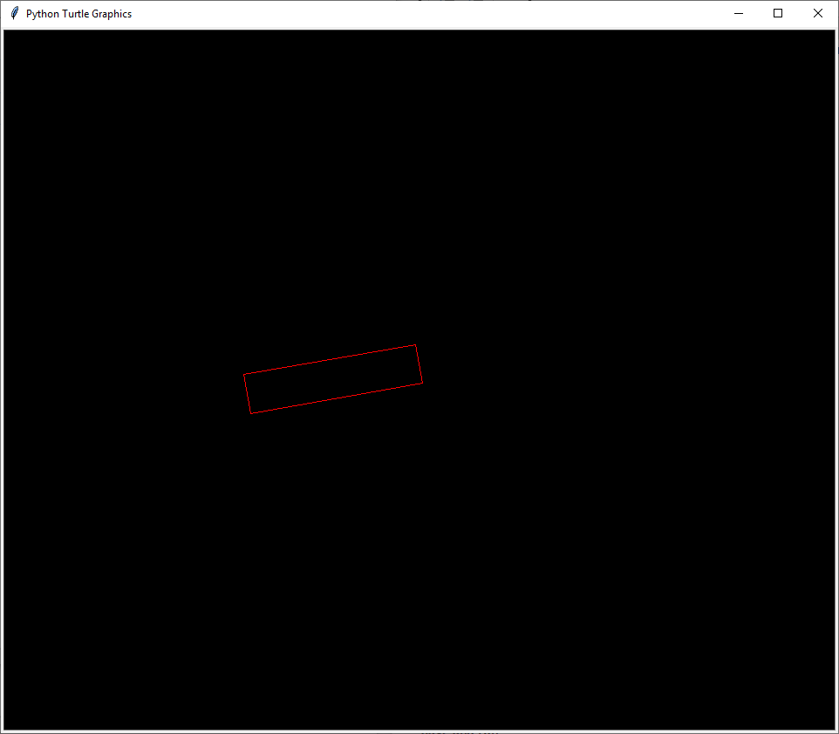

Write a program to draw a triangle on the screen
Let the screen background color be black and color of the line drawn red.

Draw a Triangle

from turtle import Turtle
t=Turtle()
t.screen.bgcolor("black")
t.color("red")
t.hideturtle()

def triangle(length,angle=120):
for steps in range(3):
t.fd(length)
t.left(angle)

triangle(200)

Save and run

Don’t be over excited yet, there’s a ton of room for improvement in our programs.

How to Draw a Circle

The circle() method is used to draw a circle and it can accept three arguments which are:

1. radius
2. extent
3. steps

The most important is radius and extent. Though, extent and steps are optional(i.e a circle can still be drawn without including them.)
The radius accepts an integer ( whole number ) which is the radius of the circle.

The extent accepts an integer (whole number) which is an angle. To cut short the technical explanation, it determines the part of the circle that will be drawn.
If you assign 360, a full circle will be drawn, 180 will draw a semi-circle.
Let’s do some coding. The code snippet below will draw a semi-circle.
Open a new file editor window and type the following code

from turtle import Turtle
t=Turtle()
t.circle(50,180)
t.hideturtle()
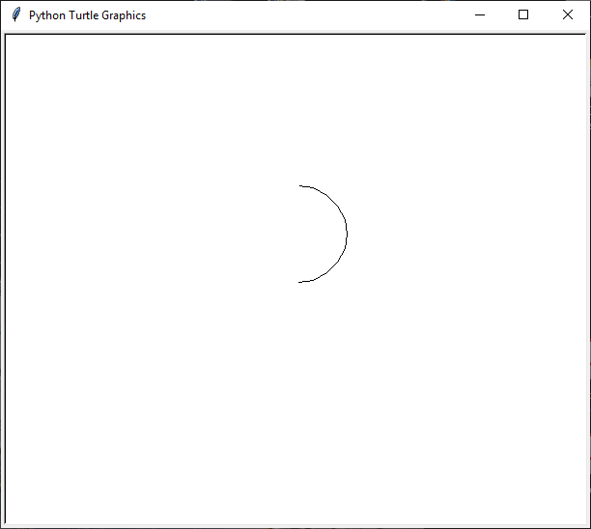
Here’s the output of the code

Well, let’s do something a bit harder so you can learn more.
from turtle import Turtle
t=Turtle()
t.hideturtle()
t.up()
t.setx(50)
t.down()
t.setheading(90)
t.circle(50,180)

The only thing strange about this code snippet is t.setx().
The method setx() positions the turtle on the x-axis leaving the y-axis unchanged.

In addition, the method sety() positions the turtle on the y-axis leaving the x-axis unchanged. In the next section, we will draw a full circle.

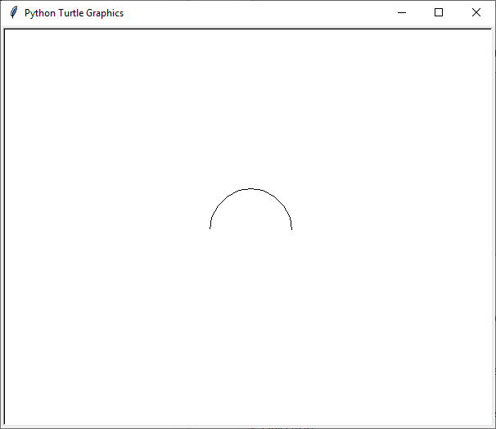
How to Raise Up the Turtle off the Drawing Surface
Imagine the turtle as a paint brush in the hand of an artist. The artist can lift up the brush off the canvas to place it on another position on the canvas.
To do a similar action with the turtle, you use this syntax below,
t.up()
To put back the turtle on the canvas, use this syntax below,
t.down()

Note: No drawing is done when the turtle is up. Drawing is done when the turtle is down.
Let me explain the following syntax by writing cool programs

Open a new file editor window and type the following code.

from turtle import Turtle
t=Turtle()
t.screen.bgcolor("black")
t.color("red")
t.goto(100,50)
t.circle(50)
t.hideturtle()

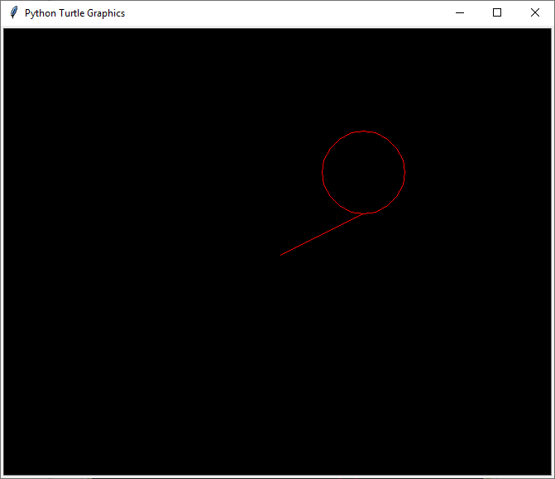
If you run the code above you will get..

From the diagram above you can observe that the turtle moved to an absolute position
t.goto(100,50))
and a circle with a radius of 50 is drawn
t.circle(50))

The next code snippet will remove the line in the diagram above.

Code snippet 2:

Open a new file editor window and type the following code

from turtle import Turtle

t=Turtle()
t.screen.bgcolor("black")
t.color("red")
t.up()
t.goto(100,50)
t.down()
t.circle(50)
t.hideturtle()

If you run the code above you will get;
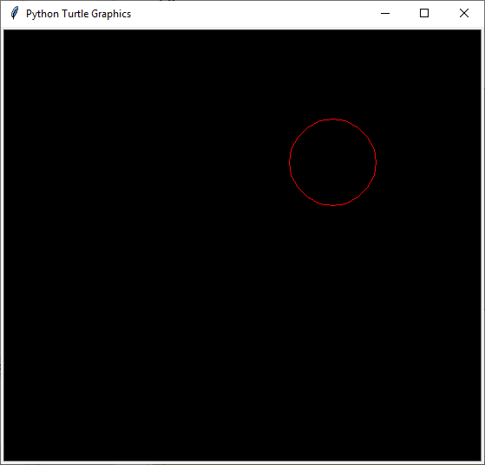

t.up() – raises the turtle up and no drawing is done when the turtle is up.
t.goto(100,50) – moves the turtle to an absolute position.
t.down() – brings down the turtle.
t.circle(50) – draws a circle with a radius of the value 50

you can replace t.up(), t.goto(100,50), t.down() with the method setposition()
The setposition() method accepts two arguments which are the coordinates x and y.

This method moves the turtle to an absolute position. If the turtle pen is down, a line will be drawn to the specified position.
How to Add colors in Your Drawing

We have been drawing many shapes but we have not applied colors to our drawing.

Here are some ways to apply colors to your drawing.

t.begin_fill() and t.end_fill() –
t.begin_fill() is called before drawing a shape to be filled with the color of the turtle. t.end_fill() fills the shape drawn with the color of the turtle after t.begin_fill() has been called. Open a new file editor window and type the following code snippet. Save it as red_circle.py red circle

from turtle import Turtle
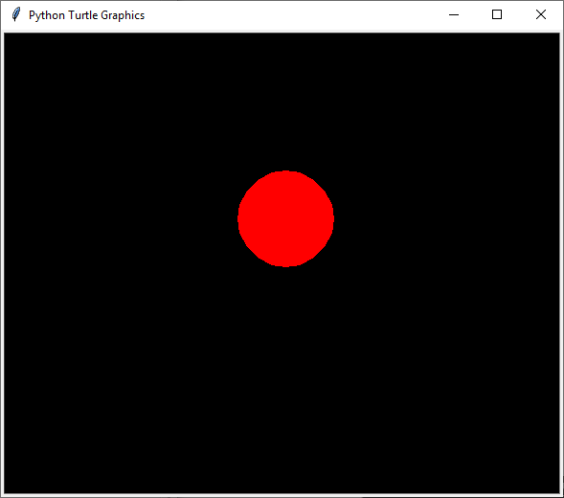
t=Turtle()
t.screen.bgcolor("black")
t.color("red")
t.begin_fill()
t.circle(50)
t.end_fill()
t.hideturtle()

If you run the code above you will get:
t.fillcolor()
This meth0d changes the color of the turtle only, when the turtle moves, the color path remains the default color (black) .

The color can be passed as a string such as:

t.fillcolor(“blue”)

The next thing we are going to do will blow your mind.

Random Walk with Turtle

Open a new file editor window and type the following code

from turtle import Turtle
import random

t=Turtle()
t.screen.bgcolor("black")

def random_drawing(turns,distance):
for x in range(turns):
right=t.right(random.randint(0,360))
left=t.left(random.randint(0,360))
t.color(random.choice(["blue","red","green"]))
random.choice([right,left])
t.fd(distance)

random_drawing(100,50)
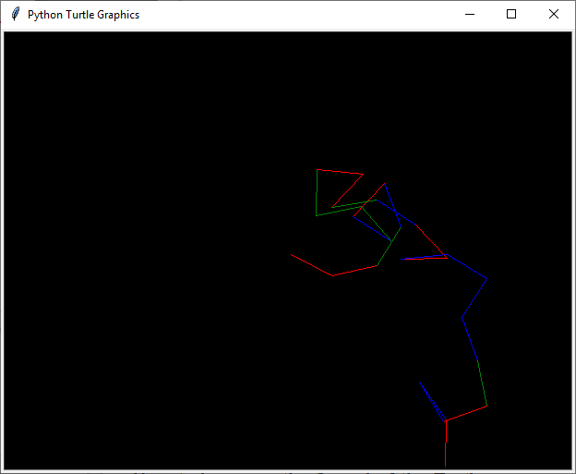

My output of the program is something like this:

Note: We can’t get the same result. Because I use the random module.

A random module picks random element in a sequence.

How to Increase the Speed of the Turtle

Imagine how long it will take for your turtle to draw something like this:

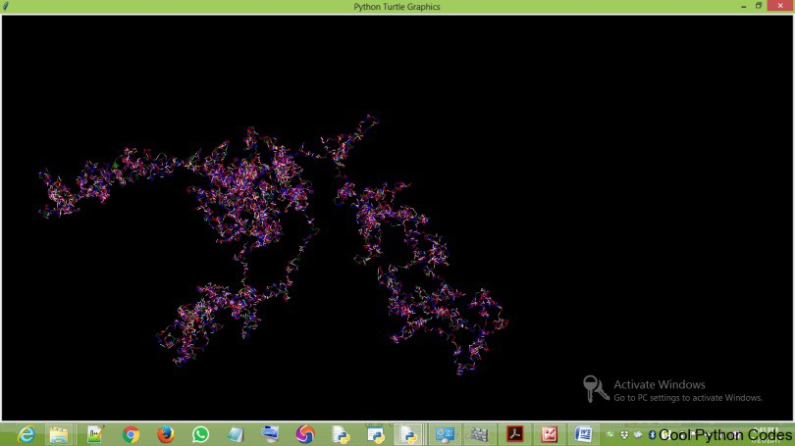

would take you a lot of time. But here’s the best part of turtle,
You can increase the speed of the turtle. How then?
t.speed() accepts an integer as an argument to set the speed of the turtle. The value 0(zero) is the fastest speed of the turtle
So to increase the speed of the program include t.speed(0) before defining the function randomwalk.

How to Write Text with Python Turtle

To write on your computer screen, use the write() method. The write() method accepts four arguments, which are:
arg– this is the string object of the text you want to write to the TurtleScreen.
move– this argument is optional and it can only be assigned to the value “True” or “False”. When True a line will be drawn below the text.
align– you assign this argument either to the left, right or center. This argument is also optional
font– this argument basically determines the font name, font size, font type of your text.
To understand this better, let’s write some codes.

Write a program to display Cool Python Codes on the turtle screen.

from turtle import Turtle

t = Turtle()
t.hideturtle()
t.write("Code Club",move=True,align="center",font=("Freestyle Script",50,"normal"))

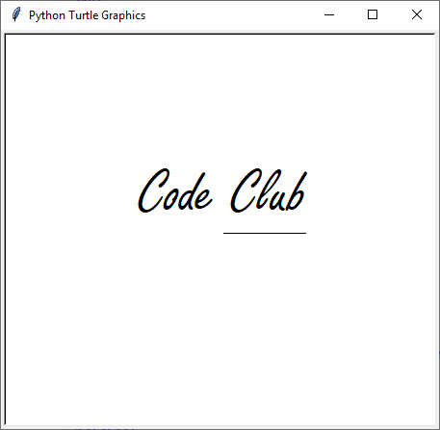
Here is the output of the program.

Lets put ieverything we’ve learned together..
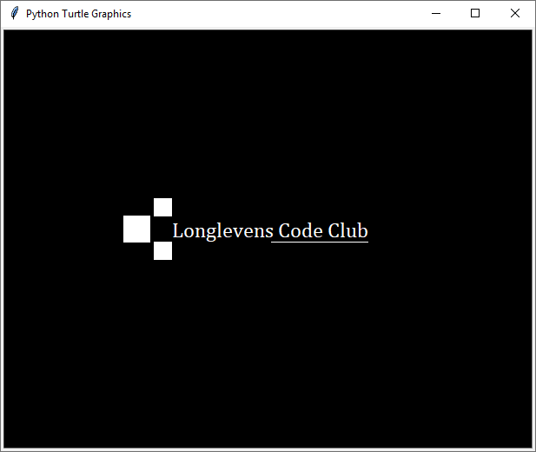
from turtle import Turtle
t = Turtle()
t.screen.bgcolor("black")
t.color("white")

def square(length):
for steps in range(4):
t.fd(length)
t.left(90)

def draw_square(x, y, length):
t.hideturtle()
t.up()
t.goto(x, y)
t.down()
t.begin_fill()
square(length)
t.end_fill()

def rectangle(length, width):
for steps in range(2):
t.fd(width)
t.left(90)
t.fd(length)
t.left(90)

def draw_rectangle(length, width, x, y):
t.hideturtle()
t.up()
t.goto(x, y)
t.down()
t.begin_fill()
rectangle(length, width)
t.end_fill()

t.write("Longlevens Code Club", move=True, align='center',font=('Cambria', 18, 'normal'))

draw_square(-135, -20, 20)
draw_square(-135, 30, 20)
draw_square(-170, 0, 30)

Can you change this program to make it your own. Add circles, colours and your name

Congratulations you get a star!

